The Other Side of Prospect
An afternoon with author Nicholas Dawidoff
and panelists Anthony Campbell,
Babz Rawls-Ivy, and Ken Rosenthal
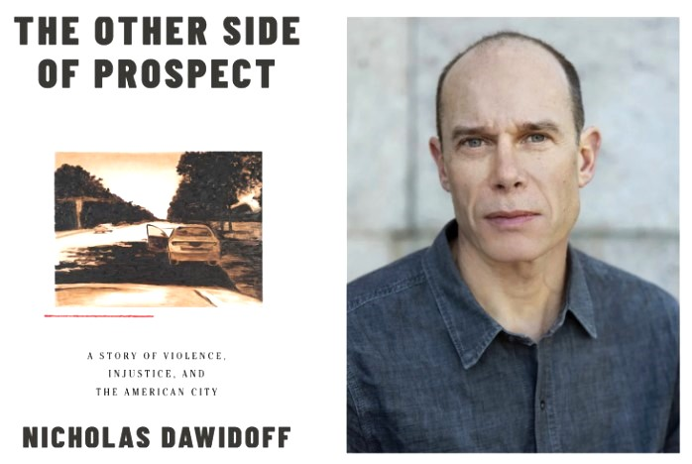

February 25, 2024 from 12-3PM
In person and virtual attendance options
Hosted by the Unitarian Society of New Haven
and the Humanist Association of CT
700 Hartford Turnpike, Hamden, CT 06517

The Other Side of Prospect is a prizewinning work of intimate reporting on inequality, race, class, and violence, told through a murder and intersecting lives in an iconic American neighborhood.

Mr. Dawidoff will give a talk with Q&A. He will then be joined for the panel discussion by Yale (and former New Haven) Police Chief Anthony Campbell, Editor in Chief of "The Inner-City News", Babz Rawls-Ivy, and lawyer for the wrongly convicted, Ken Rosenthal.
Refreshments will be provided.

Pre-registration appreciated for In-person, required for virtual attendance, using this QR:
For more information, write to are@usnh.org

